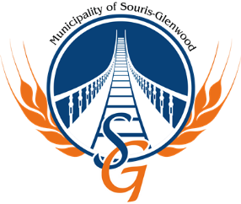
Seasonal Rural Tractor Mower Operator
Municipality of Souris-Glenwood
Public Works Department
Job Summary:
The Tractor Mower Operator will be responsible to mow ditches and complete a variety of other tasks as per day to day operations of the Public Works Department.
Responsibilities:
- Mowing road side ditches
- Culvert Maintenance/Locate
- Fixing signs
- Perform regular maintenance on all equipment
- General labour as required
Qualifications:
- 3-5 years’ experience in operating heavy equipment including tractors, motor graders, loaders, gravel trucks is preferred
- Possess heavy equipment training is considered an asset.
- Road maintenance experience
- Must be mechanically inclined
- Must possess Class 5 driver’s license, however Class 1 driver’s license is considered an asset.
- Wage will be based on experience and qualifications.
Closing Date: March 28, 2024
Interested candidates are invited to forward their resume to:
Attention: Dave Dobson, Operations Manager
Municipality of Souris-Glenwood
100 2nd St S. Box 518
Souris, MB R0K 2C0
Fax: 204-483-5203
Email: sg.pwm@mtsmail.ca
We thank all interested applicants; however, only applicants selected for an interview will be contacted.

